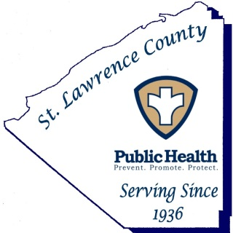

St. Lawrence County Public Health Department

Dana Olzenak McGuire, PT, PhD ■ Public Health Director

80 State Highway 310, Suite 2 ■ Canton, New York 13617-1476
Phone: (315) 386-2325 ■ Fax: (315) 386-2203

Press Release
Date: January 16th, 2019
FOR IMMEDIATE RELEASE
Contact: 315-386-2325

January is Cervical Cancer Awareness Month.

Canton, NY January 16th, 2019 St. Lawrence County Public Health is reminding residents that January is Cervical Cancer Awareness Month. Nearly 13,000 women are diagnosed with cervical cancer annually, and more than 4,000 die as a result. However, the disease is preventable with vaccination and appropriate screening.

All women are at risk for cervical cancer. It occurs most often in women over age 30. Almost all cervical cancers are caused by the Human Papillomavirus Infection (HPV). In addition to having HPV, a woman’s chances of getting the disease increases if she smokes, has HIV, uses birth control pills for more than 5 years, or has given birth to three or more children.
Thankfully, cervical cancer can be prevented by:
- Getting the HPV vaccine to protect against the types of HPV that cause 90% of cervical cancers. The Centers for Disease Control and Prevention recommends the vaccine for preteens (both girls and boys) aged 11 to 12 years, but can be given as early as age 9 and until age 26;
- Woman ages 21-65 should get a Pap test (or Pap smear) every 3 years to look for cell changes on the cervix that might become cervical cancer if they are not treated appropriately;
- Getting the HPV test to look for the human papillomavirus that can cause these cell changes;
- Following up with your doctor if test results are not normal;
- Not smoking; and
- Using condoms during sexual activity.

With screening tests and the HPV vaccine, cervical cancer is highly preventable! When cervical cancer is found early, it is highly treatable and associated with long survival and good quality of life. Talk with your doctor today if you believe you’re at risk for cervical cancer.
For information on cervical cancer, human papilloma virus (HPV), or the HPV vaccination, please call the Public Health Department at 315-386-2325.
###

