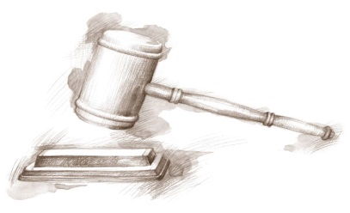
St. Lawrence County
BOARD OF LEGISLATORS
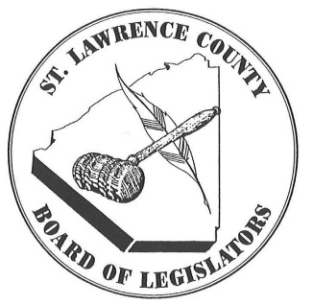
48 Court Street, Court House
Canton, New York 13617-1169
Telephone: (315) 379-2276

Fax: (315) 379-2463

Website: www.stlawco.org
Instagram: st.law.co

TBD, Chair Ruth A. Doyle, Administrator
TBD, Vice Chair

District
& Party Legislator Address Telephone

12 (R) Burke, John 424 Lacomb Road, Norfolk 13667 315-705-4585 (H)
Email: jburke@stlawco.gov 315-842-6788 (C)

15 (R) Curran, Rita E. 9 Green Drive, Massena 13662 315-705-8944 (C)
Email: rcurran@stlawco.gov

6 (R) Denesha, Larry 2924 CR 17, DeKalb 13630 315-854-2733 (C)
Email: ldenesha@stlawco.gov

9 (D) Fay, Daniel 30 Clark Street, Canton 13617 315-386-5228 (H)
Email: dfay@stlawco.gov

2 (R) Forsythe, David 564 Murphy Road, Lisbon 13658 315-854-0550 (C)
Email: daforsythe@stlawco.gov

13 (R) Gennett, John 1350 County Route 53, Brasher Falls 13613 315-514-4642 (C)
Email: jgennett@stlawco.gov

10 (D) Haggard, Margaret I. 8 Clinton Street, Potsdam 13676 315-528-2842 (C)
Email: mhaggard@stlawco.gov

8 (R) Hull, Benjamin 1826 State Highway 345, Madrid 13660 315-244-3393 (C)
Email: bhull@stlawco.gov

3 (R) Lightfoot, Joseph 6138 SH 37, Ogdensburg 13669 315-393-3514 (H)
Email: jlightfoot@stlawco.gov 315-322-1968 (C)

7 (R) Perkins, Rick 43 Hotaling Island Drive, Potsdam 13676 315-261-8955 (H)
Email: rperkins@stlawco.gov

1 (R) Reagen, James E. 525 New York Avenue, Ogdensburg 13669 315-393-2154 (H)
Email: jreagen@stlawco.gov 315-323-3446 (C)

4 (R) Sheridan, William J. 29 Livingston Drive, Hammond 13646 315-324-6093 (H)
Email: wsheridan@stlawco.gov

5 (R) Smithers, II, Harry A. 250 Old Route 58 South, Gouverneur 13642 315-287-4236 (H)
Email: hsmithers@stlawco.gov

14 (D) Terminelli, Nicole A. 23 Walnut Avenue, Massena 13662 315-842-8874 (C)
Email: nterminelli@stlawco.gov

11 (R) Webster, Glenn J. 396 County Route 48, Norwood 13668 315-244-0757 (C)
Email: gwebster@stlawco.gov

TBD: Chair, Operations Committee
TBD: Chair, Services Committee
TBD: Chair, Finance Committee

